DOWNLOAD MS SQL SERVER

And Save Your Server Name from SSMS

OPEN NEW WORKSHEET > Go to Data Tab > Get Data > From DATABASE > Connect to SQL Server

ENTER SERVER & DB NAME  
(Example Server Name: DESKTOP-BR71MUS\MSSQLSERVER01DB Name: Pizza_DB)

**FOLLOW THE STEPS BELOW:**

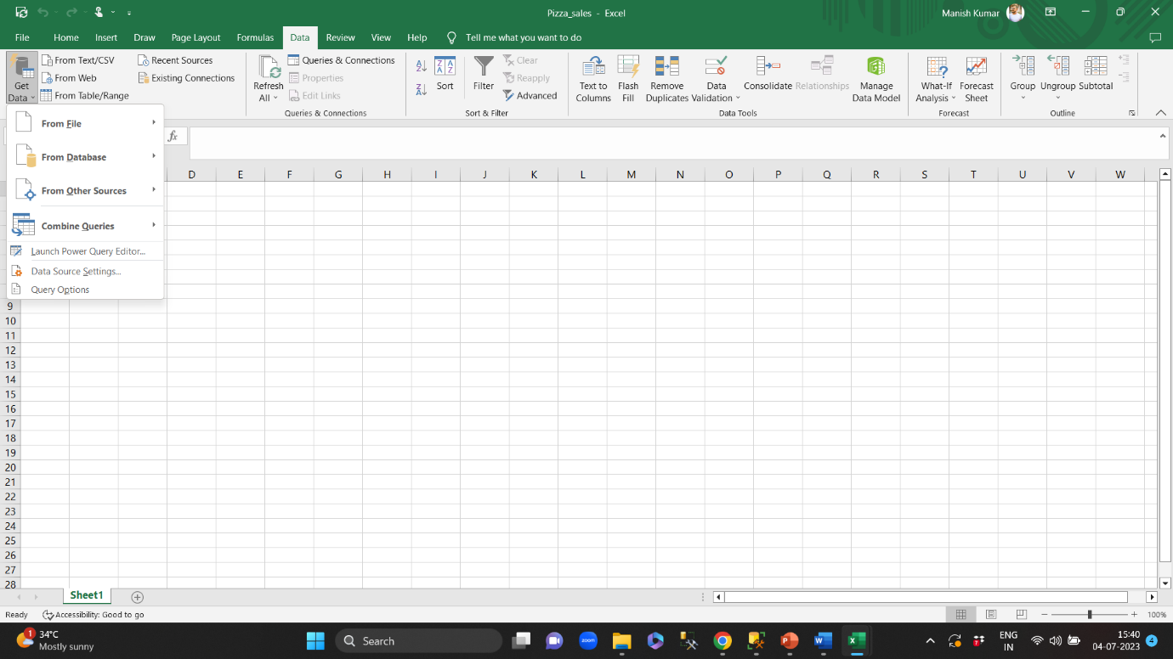

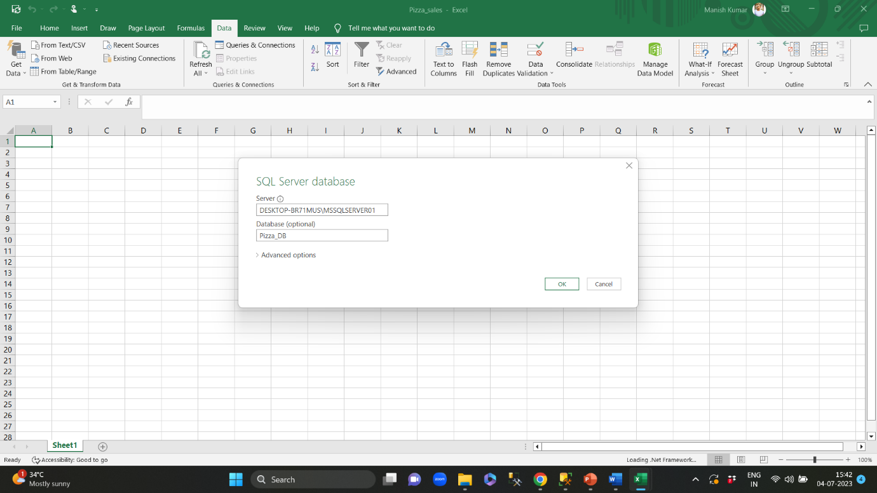

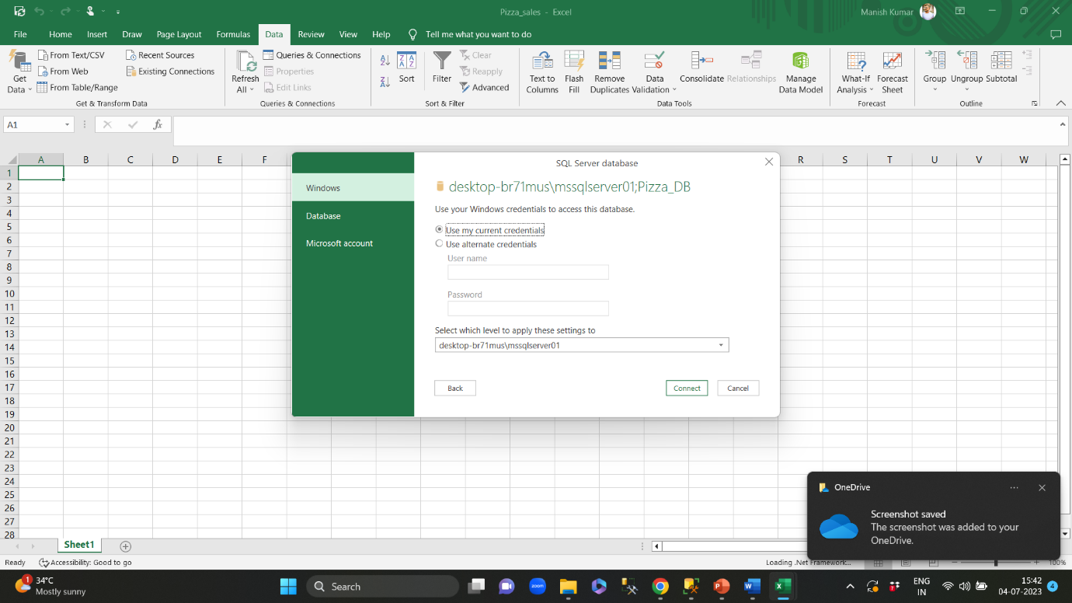

CLICK ON CONNECT AND FINISH (If ENCRYPTION pop-up comes, click OK and proceed)

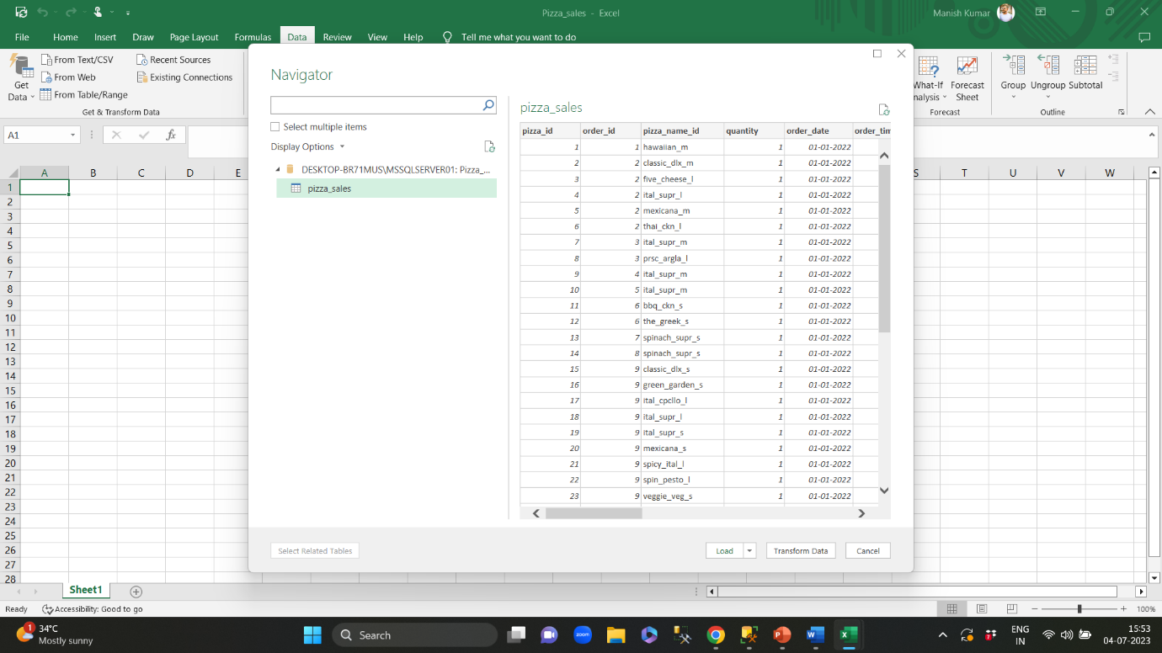

**Once you get this window, click on LOAD to get started.**